Instructions to Fabricate Fly Bubbles

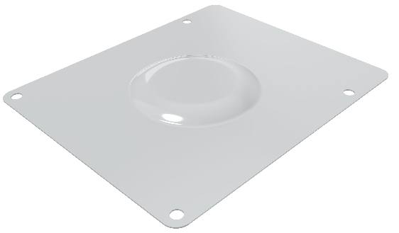Tools and Materials Needed:

* 3D-printed or machined-aluminum vacuum-forming buck:
  + THERMOFORM BUCK – PLATE
  + THERMOFORM BUCK – BUBBLE
  + 2x 2-56x1/4” 82° Flat Head Screws
    - <https://www.mcmaster.com/91771A104/>
* Lasercutting Alignment Jig
  + LASERCUTTING ALIGNER
* Clear Plastic Sheet, 0.020”-Thick
  + Recommended: Grafix Ultra Clear 0.020” Polyester Sheet, 12”x12”
    - <https://www.amazon.com/Grafix-Craft-Plastic-Sheets-12-Inch/dp/B001K7N66W/ref=sr_1_2>
* Vacuum Former (and 3-5HP wet/dry vac if needed for the vacuum former)
  + Recommended: Mayku Formbox with a 87737-49 (5HP) Shop-Vac
* Lasercutter
* Mold Release, spray-on & no-residue
  + <https://www.mcmaster.com/1409K42/>
* Lint-free cloth
* 95%+ isopropyl alcohol
* 9”x9” sheet of thin metal
  + Used for holding the buck in the Formbox during pre-heating

Preprocessing:

* The PDFs and STP files included with these instructions contain the parts needed for the buck and for the lasercutting alignment jig. Submit the STP files to your 3D printing service of choice or the STP and PDFs to your machining service of choice ([GoProto](https://goproto.com/) and [Protolabs](https://www.protolabs.com/) have both 3D printing and machining options). A buck machined from aluminum will be the best option for long term use, but a 3D-printed version can work for a few test runs (the 3D-printed part will warp over time and may eventually crack). If 3D printing is chosen for the buck, then be sure to choose a material that is not a thermoplastic (SLA/DLP/MSLA/PolyJet will work. FDM/FFF will not work). Further, you will be responsible for polishing the top face of the 3D printed THERMOFORM MOLD – BUBBLE part. The alignment jig can be 3D printed from any material
* The 12”x12” polyester sheets will need to be trimmed down to ~9”x12” to fit on the Mayku Formbox. Other vacuum formers may not require this modification to the material
* Assemble the two buck parts together with two flat head screws, as shown below
* Clean the surfaces of the buck and apply mold release to the top and sides
* Prepare the vacuum former. The settings below apply to the Mayku Formbox – experimentation will be needed if another vacuum former is used instead
  + Temperature: 4
  + Time: 20 seconds

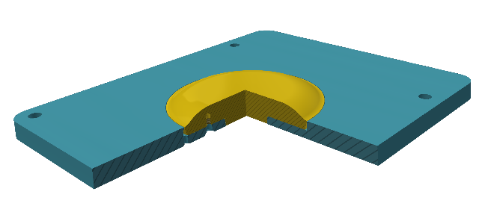Forming Process:

* Preheat the buck up to ~60°C by placing it in the Formbox near the heater for several minutes
* Place the buck in the center of the Formbox in preparation for forming
* Remove the plastic coating from the material and wipe the surface down with a lint-free cloth
* Insert the material in the Formbox and begin the heating process
* Wait until the material droops sufficiently (or until the Formbox beeps)
* The Formbox automatically turns on the vacuum when the material is pulled down. If your vacuum doesn’t do this, turn your vacuum on now.
* When ready, pull the material down over the buck and allow the part to be formed
  + On the Formbox, it is recommended to gently pull down on the carriage until the detent has been cleared, then quickly pull the material down over the buck
  + If the bottom of the drooping plastic is allowed to touch the top of the bubble of the buck for too long relative to the rest of the buck, it can cause undesirable ripples in the formed part, so be quick with the pull
* While the plastic is still somewhat pliable (after ~5 seconds on the buck), quickly yank the formed sheet from the buck and relocate the buck to the center of the Formbox
* Install a new sheet of material and begin the process again
* Each forming process should transfer sufficient heat to the buck to keep it hot, but if artifacts begin forming in the bubble of the formed parts, then it is likely because the buck has cooled down too much

Cutting Process:

* Install the aligner in the lasercutter and align the cutting file to the aligner
* Load a formed bubble into the aligner, as shown below. Press down gently to ensure the bubble is level and centered in the aligner
  + It is recommended to place a small swatch of lint-free cloth inside the aligner under the bubble to protect the surface of the bubble when it drops out after lasercutting

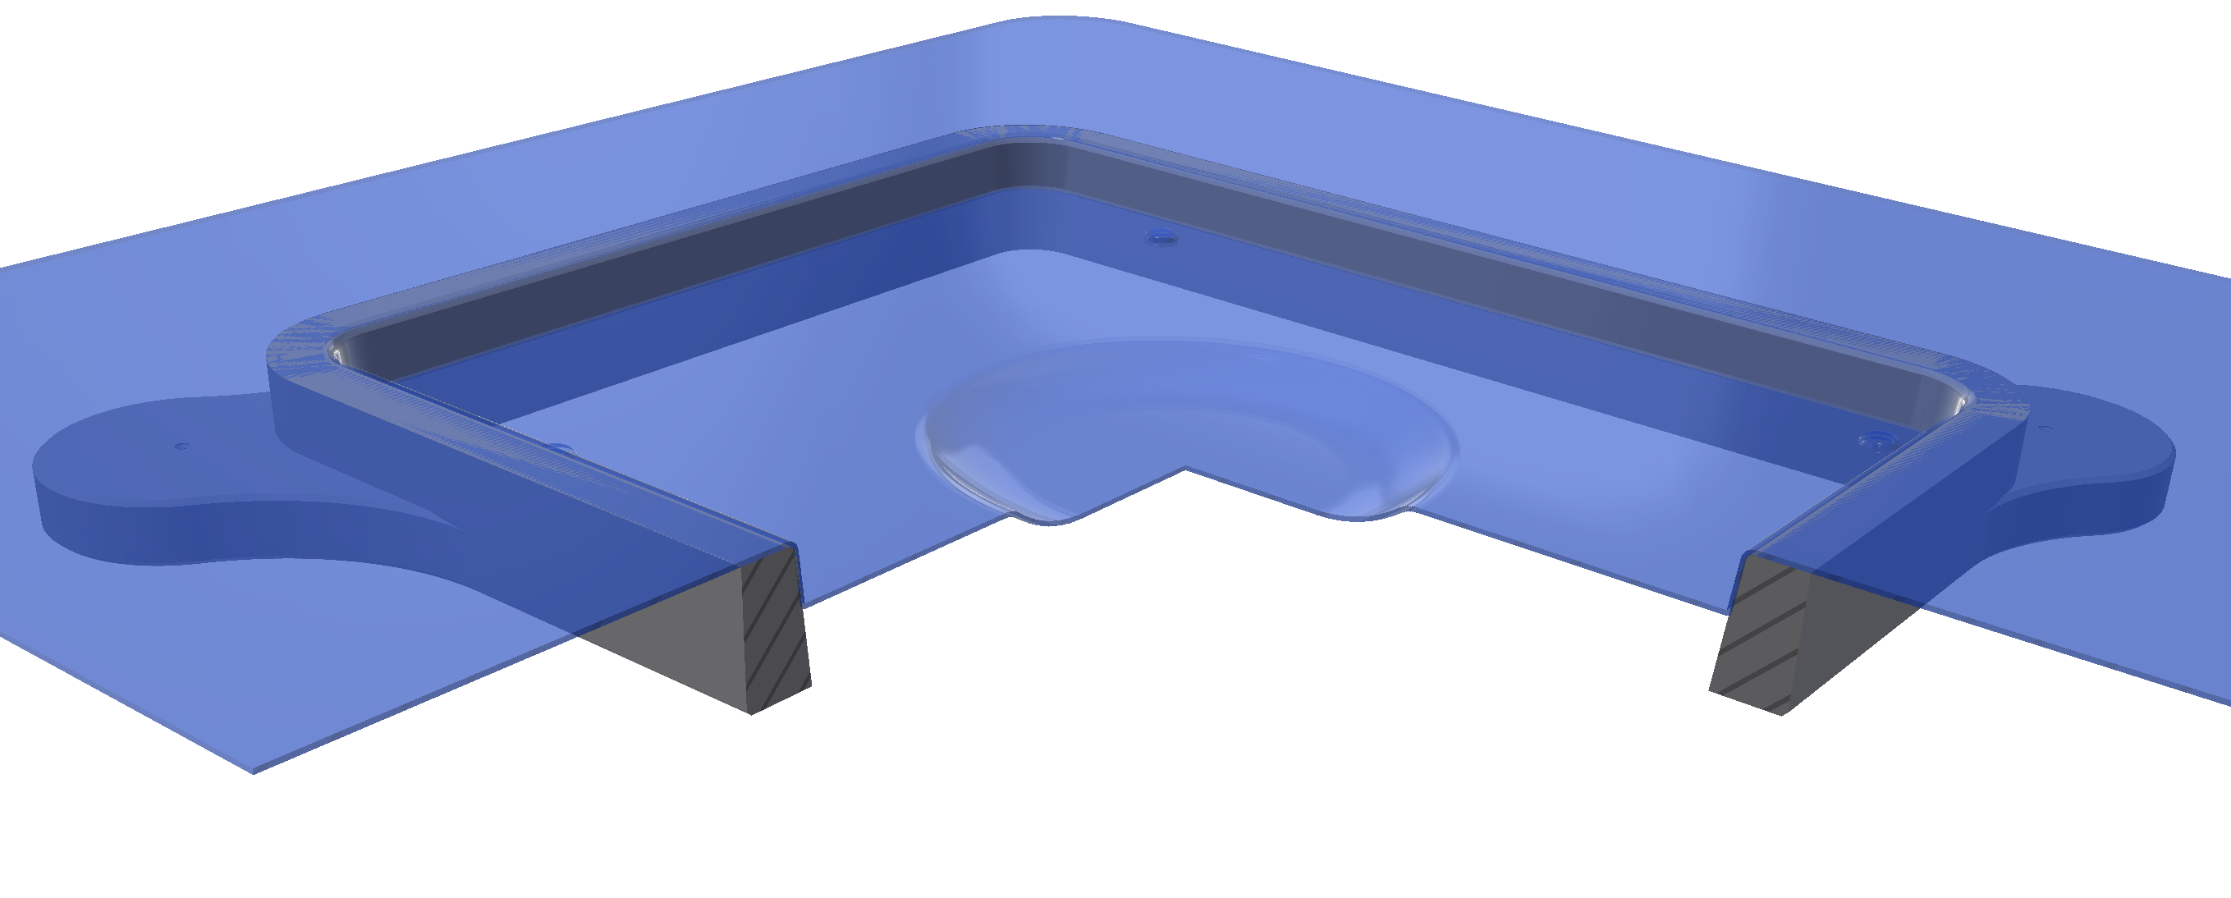

* Open and run the “LASERCUTTING OPERATIONS.PDF” file (shown below). The red objects in the file should just be used for locating the aligner. The black and blue objects are for cutting

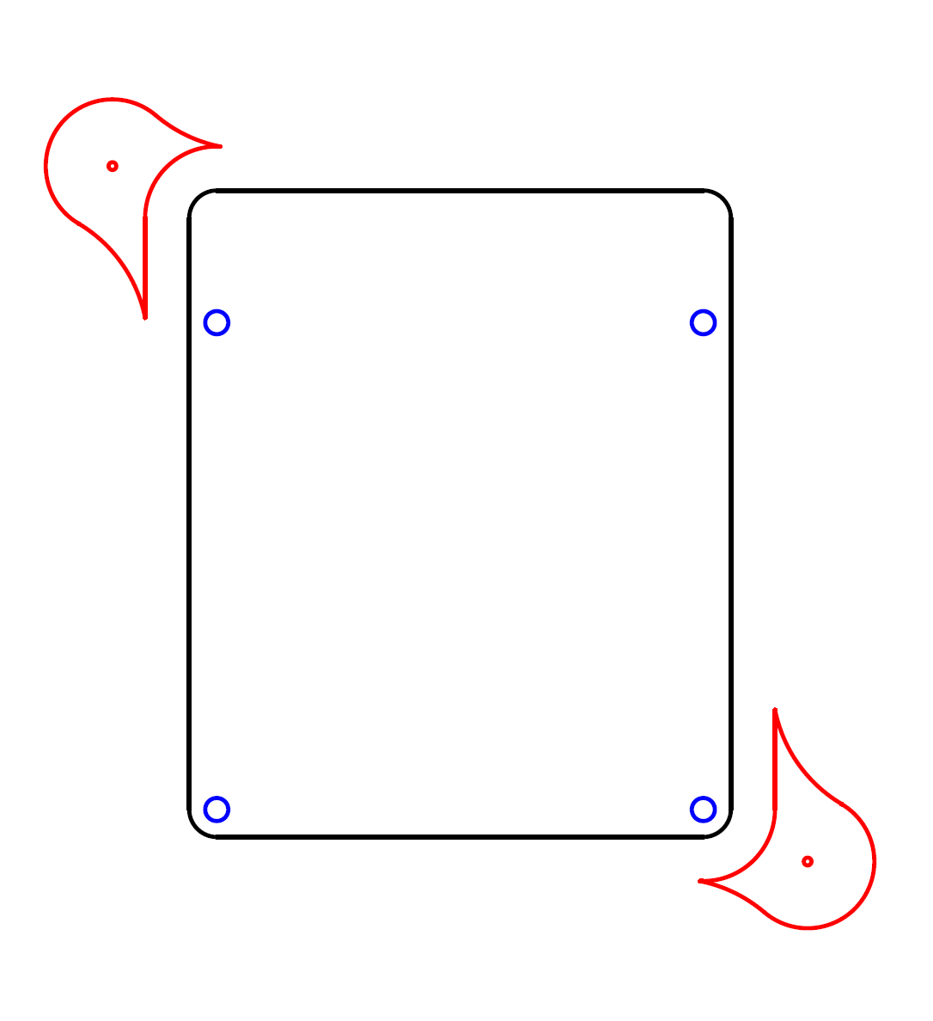

* Gently wipe the surfaces of the cut part with an alcohol-dampened lint-free cloth to remove any residue left by the lasercutting fumes
* Ensure the alignment holes in the cut bubble fit well with the mating platform in the cartridge. Otherwise, lasercutting settings need to be adjusted before additional bubbles are cut

Notes:

* Expect early attempts at this process to fail. Order extra material accordingly
* Common causes of poor surface quality in the formed bubble:
  + Surface of the buck was not polished sufficiently
  + Not enough/too much mold release was applied
  + Material was not wiped free of contaminants prior to forming
  + Material was not allowed to heat up enough/heated up too much
  + Buck cooled down/was preheated too much
  + Formed bubble was removed from the buck too early/late